[1]

Audio Compression by Using

Discrete Cosine Transform Compression and Dynamic Sample Elimination

Goktug Kayacan, Caner Coskun, M. Talha Tuncak

*Abstract*— Audio compression is the process of reducing a signal’s dynamic range. Dynamic range can be described as the loudest and quietest parts of an audio signal. By reducing this dynamic range, these signals can be reduced to a state where the perceived quality is still the same, but the physical space taken up by the signal is reduced. The application of this process is called compression. This study attempts to recreate an implementation of a commonly used compression method while adding an amalgam of different compression methods to apply further reduction of any given audio signal.

*Index Terms*— Data compression, Audio compression, Digital signal processing, Discrete cosine transforms, Psychoacoustics

# INTRODUCTION

Audio compression is a well-studied area of digital signal processing and psychoacoustics. The study of audio compression is concerned with reducing the physical size of a signal while retaining the perceived integrity of the signal. For any audio file there are three several factors which are directly related to the physical size of the signal, such as; number of samples (length) and sampling frequency. Sampling frequency for audio files is related to the highest possible frequency and given sample can contain. By taking the study of psychoacoustics into account which is the study about how humans perceive and understand sounds, it is possible to take advantage of concepts such as “Human hearing threshold”, “Masking” and “Equal loudness contours” it becomes possible to reduce certain regions of the signal with data redundancy while still being able to keep the perceived quality intact.

Although there are a multitude of compression methods, this project makes use of two compression methods: “Discrete Cosine Transform Compression” and a method to detect and remove irrelevant samples of data by applying a light variation of masking amalgamed with classic compression methods.

Although the aforementioned model of compression that is applied in this project is not directly comparable with compression methods such as MPEG due to MPEG compression being a lossless compression method, the model built in this study can be considered to be different take on lossy audio compression.

# Problem specification

The primary goal of this study is to implement two different functional, single channel, audio compression methods with one method being lossless compression while other one being lossy compression.

Compression methods should output a compressed variant of the original audio signal while keeping the perceived integrity in acceptable terms. The loss of data for the lossy method is acceptable but it should be possible to recover the lossless method’s output through the application of methods such as interpolation. However, note that recovery of these signals is not in the main scope of this study.

The resulting audio from application of both or a single method should produce a single that is smaller in physical size by a perceivable margin. The estimated drop in size should be at least five to ten percent from lossy method and ten to fifty percent for lossless method while keeping the perceived quality within acceptable limits.

# Data

Data for this project is going to be tested on three types of audio signals dependent on the content of the given signal.

These are:

1. Audio with only Music
2. Audio with only Speech

By using these types of audio-files for compression it becomes possible to understand the effects of compression on different types of perceived information.

Multiple types of audio files are going to be tested with each having different sampling rates to show the effect on compression on audio signals with different sampling periods.

The length of audio files is arbitrary as the project is concerned with percentage drop in physical signal size to compare the effectiveness of the compression.

# Evaluation Criteria

The primary criterions for evaluation of this project are going to be two factors; the percentage drop in the physical size of the audio signal (in terms of samples) and the auditory difference of the signal for individual listeners. Therefore, the primary quantitative data is the reduction in signal length and qualitative data is the perceived quality of the audio. Each method can be compared within these given metrics to provide a comparison between the methods. Note that “distortion” in the audio is evaluated by the responses from *7* different listeners.

# Approach

The project is built in MATLAB, with each method contained within their own MATLAB functions with certain sub-methods binding the application of these methods together. The approach taken for both methods and the binding methods are described in detail under the respective headings.

## Discrete Cosine Transform Compression

This method of compression is commonly used in a large majority of high-grade compression algorithms such as MPEG due to low computational cost and high performance of the DCTC algorithm.

The method works by taking a one-dimensional, long audio vector, the audio file is read by MATLAB. The audio file is processed compressed by the chosen ***cast.*** The application of the discrete cosine transform is applied to the frames of the recording which are simply a region of the recording. *Equation-1* shows the determination of the “***sampleFactor***” which is used to separate the discrete cosine transform of a frame with given size of “***frameLength”.***

$sampleFactor=Ceil(\frac{frameLength}{cast})$***(Equation-1)***

By applying this every frame for a total frame number of $number of frames=\frac{recordingLength}{frameLength}$ the signal frequency range can be reduced by the ratio of the ***cast*** value. For example: If the ***cast*** value is given as “2”, and the sampling frequency of the original signal is “8kHz”, the resulting signal from this method is going to have frequencies bounded within “0” to “4kHz” range. After the application of DCT to each frame of the audio signal, the signal is also down sampled by the ***cast*** amount to normalize the number of samples to the sampling frequency in accordance to the original signal.

By applying this method fully, the output audio signal’s length is effectively divided by the ***cast*** factor. Do note that however, ***cast*** can only be positive integer values. For most cases a ***cast*** value above sixteen or more is going to result in an inaudible output due to overly compressed higher frequencies of the audio signal.

## Dynamic Sample Elimination

The idea behind this method is roughly based around the application of *temporal masking* and *hearing threshold*s. The application of this method is slightly lengthier than DCTC and requires more system resources. Algorithm works by splitting the audio signal into frames, with each frame having a frame length in seconds as ***frameLengthSeconds*** and ***overlapRatio*** which is a value between zero and one, indicating the amount of “frame shifting” done for a frame based on the frame’s length. Higher ***overlapRatio*** results in a higher range of shared samples between each individual colliding frame. After creation every frame, the samples of the frame are multiplied by the *hamming window*to “soften” the transitions and avoid creation of *clipping* which results in unintended noise due to the frequency ripples occurring from the sharp transition. By using this comparatively more sophisticated framing method, it becomes possible to evaluate each of these frames per individual basis and apply different operations. Framing operation is described in **Figure-1**

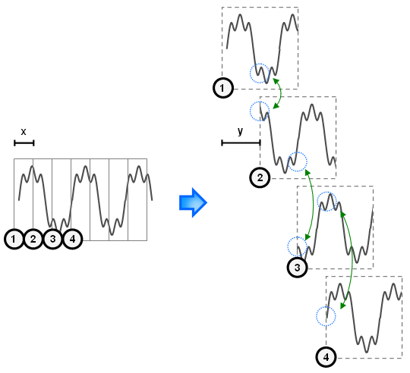

**Figure-1:** Framing and Frame Shifting

Application of this method not only allows for better precision when operating on the frames but also allows for audio signals which requires higher-operating precision such as speech signals and signals that contains speech and music.

Following this framing process, the new method, *Dynamic Sample Elimination* to every individual frame, application of this method produces a new frame which is the modified and reduced version of the original frame*.*

Calculating number of samples for the length of each frame and the frame shift requires multiplying these terms that are in seconds by the sampling frequency.

The method has a single parameter which determines the percentage of samples that are removed from each frame. Which translate into what percentage of the audio signal is going to be eliminated. This variable is called ***scalingFactor,*** usually this value is between 0.01 (1%) to 0.05 (5%). If this factor is too high, it is going cause *clipping* in the audio due to loss of data and add noise at certain frequency bands which is very hard to remove without taking many extra steps.

The compression works by calculating the total amount of samples that are going to be removed, which is calculated using*;*

$$\#Samples to Remove=floor(frameLength*scalingFactor)$$

After which the thresholds for sample search is calculated. This is done by calculating the *Logarithmic Energy (Log energy)* of the frame which is calculated as given in the *Equation-3* below.

$Log Energy=20*\log_{10}({framgeMagnitude}^{2})$*(Equation-3)*

The energy is normalized to zero using *Equation-4.*

$NLogE=LogEnergy-max⁡(LogEnergy)$*(Equation-4)*

After this calculation mean of the *NLogE* is found, upper and lower thresholds are determined by multiplying the *NLogE* value by 1.19 and 0.9 respectively. These values are picked to roughly simulate the non-linear range of human sound discrimination in time.

Any sample with energy that falls within these boundaries are marked and tested to find if the sample is within a state of transition. This state is determined by comparing the current sample to the previous and next sample to see if the previous sample is higher than current sample while the next sample is lower than current sample or the other way around. Once a sample has been determined to be in transition, the sample is marked for removal. If there aren’t enough sample marked, the thresholds are expanded by %6, for the total ratio of %106 of the upper threshold and the lower threshold is dropped by 6%, resulting in 94% of the original threshold value, effectively increasing the total covered area.

Once enough samples have been marked for removal, these samples removed, and neighboring samples are “softened” by a margin of the removed sample’s magnitude. The neighboring samples are determined by a percentage of the total length of the frame which is usually around one to three percent of the frame length. Smoothing is simply done by adding a portion of the magnitude of the removed sample and decreasing this portion as the samples further from the removed samples are smoothed out. This smoothing process heavily reduces the ripple effect that comes from annihilating seemingly random samples but does not negate it completely.

In order to negate or heavily mitigate the noise generated from this process, the ***scalingFactor*** should be taken lower or the ***overlapRatio*** *and* ***frameLengthSeconds*** should be changed. By taking a lower ***frameLengthSeconds*** value, it becomes possible to completely negate this ripple effect at the cost of processing speed. Note that this is not a conventional speech processing or audio processing problem. Therefore, picking what could normally be a “too short” frame length such as one millisecond is acceptable in this case.

After the frames have been reduced, the audio signal is rebuilt using the **Overlap and Add** method. This method reconstitutes the original signal with slight data loss at the beginning and at the end of the signal, although this loss is very minimal and near negligible in this case.

Results are shown in a spectrogram comparison to show the frequency change over time, waveform comparison to show how the waveform changed. The produced audio signal is also saved in *.wav* format to make qualitative measurements by listeners to compare original and compressed audio signal.

# Results and analysis

Due to the amount of variations for the parameters, only a handful of the results are going to be analyzed in this section. Further analysis of the specific parameters should follow the pattern that can be observed in this section.

## Analysis of DCTC

### Pure Music Audio Signal

The spectrogram and the waveform of the original non-compressed file for pure music audio signal is given as *Figure-2.*

**

**

***Figure-2:*** *Original Signal spectrogram and waveform*

Further analysis can be done by changing the DCTC compression factor to “*2”* The related spectrogram and waveform are given as *Figure-3.*



***Figure-3:*** *DCTC scaling factor=2*

As observable from *Figure-3*, The waveform has seen no perceivable change while the frequencies of the spectrogram have been “squashed” down by half the original range. When listened, the audio is perceived as “mildly blurry” as the audio sounds deeper than usual due to frequency limitations.

Further increase in the scaling factor drops reduces the frequency range further and causes the audio to be perceived “deeper” and “blurrier”. The size of the file also halves and drops down to 367KB from the original 733KB

### Speech Signal

The spectrogram and the waveform of the original non-compressed file for pure speech audio signal is given as *Figure-4.*

 

***Figure-4:*** *Original Signal spectrogram and waveform*

The speech signal is a recorded audio file consisting of four individual words recorded at 1.6kHz

* *

***Figure-5:*** *DCTC scaling factor=2*

Applying the compression method gives a result similar to the previous audio file but the loss of perceivable quality is much lower. With further compression, audio becomes deeper until the speech is indistinguishable from low frequency hum. The file size also halves as it drops from the original size of 124KB, down to 62KB.

## Analysis of DSE

Evaluation of DSE is more involved than evaluation of DCTC as there are more parameters to consider when analyzing the outputs. The parameters that are being considered as variables are: ***frameLengthSeconds, overlapRatio*** and ***scalingFactor.***

Note that the original audio files are not given in this section as the original graphs for music signal is given in ***Figure-2*** and original graphs for speech signal is given in ***Figure-3.***

Testing is done by changing a single variable while keeping the others static except for ***overlapRatio*** as this value has a very specific effect on the signal, separate from others. For the tests done in this section overlap is kept at 50%.

### Pure Music Signal

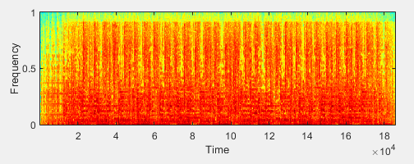 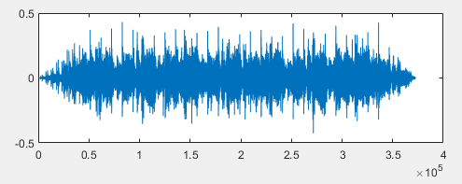

**Figure-6:** DSE applied for 1% reduction and 5ms frame length

Due to the density of the energies, even removing a total of one percent of the signal causes clipping and stutters in the signal. By reducing the size of the frames, amount of clipping can be reduced. *Figure-7* shows this behavior by taking the frame size as 1ms.

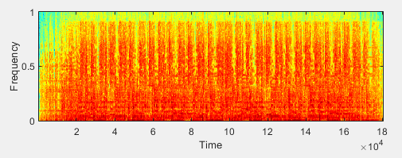 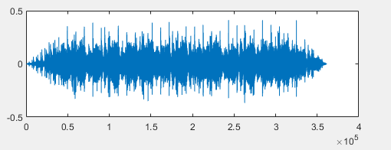

**Figure-7:** DSE applied for 1% reduction and 1ms frame length

In both cases file loses 1% of total file and drops to 706KB compared to original 733KB.

A higher ***scalingFactor*** is used, and results are given as in **Figure-8,** where the effect is still persistent but not as much.

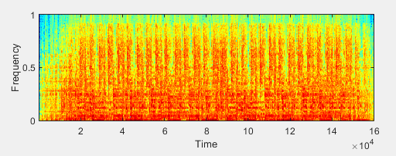 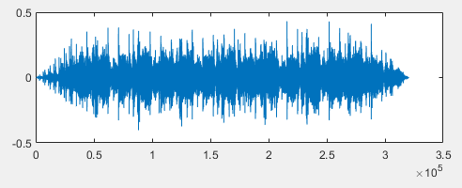

**Figure-8:** DSE applied for 5% reduction and 1ms frame length

The Test done with parameters given for *Figure-8* causes the perceived audio to change dramatically while keeping the musical part intact. The “speech” within the audio file distorts and becomes inaudible, however. This is due to the words within the speech being the samples that are matching the energy thresholds.

The resulting file also drops exactly 5% in size, down to 626KB.

Note that the certain frequencies have became sparse, this is a side effect of clipping occurring from the removal of 5% of the samples.

### Pure Speech Signal

Application of this method have a tendency to change speaker’s pitch period. Due to this, frame lengths needs to be much lower compared to music in order to have an acceptable amount of effect on the perceived quality.

***Figure-9*** shows application of this method in one such case.

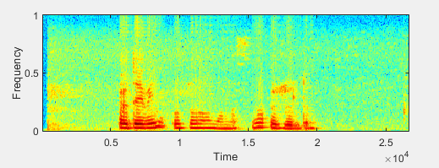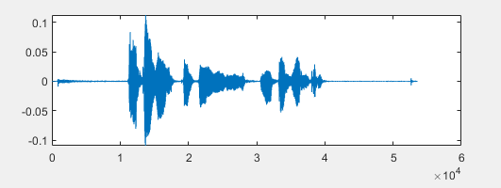  
**Figure-9:** DSE applied for 5% reduction & .5ms frame Length

By reducing the frame length further, a greater perceived audio quality can be achieved for a trade-off between processing time. One such example is given in ***Figure-10*** to show the lowest possible ***frameLengthSeconds*** and highest possible ***scalingFactor*** combined to give the best possible trade-off between quality and compression.

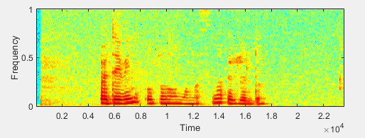

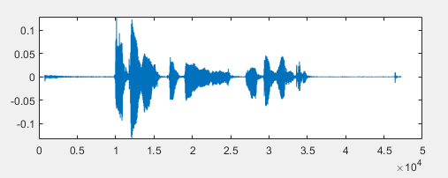

**Figure-10:** DSE applied for 10% reduction & .5ms frame Length

Although the resulting file in ***Figure-10*** is comparable in terms of quality to the sate given in ***Figure-9,*** the quality of the audio is still somewhat effected although it is nearly unnoticeable to most listeners. The file size dropped from 124KB to 93KB which is a significant drop compared to the minimal loss in audible integrity.

## Analysis of DCTC + DSE

By using both methods on the same file, the dynamic between the two compression methods can be better observed. The variables in this section are all variables combined in the previous two section.

### Pure Music Signal

In order to properly compare data, the variables in this section are the ones given in the previous sections. For **Figure-11,** the scaling factor is 2 and the samples have been reduced by 1% of the original signal with 5ms frames.

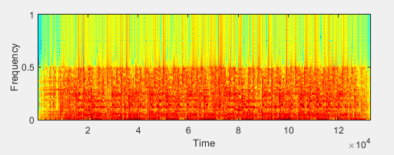

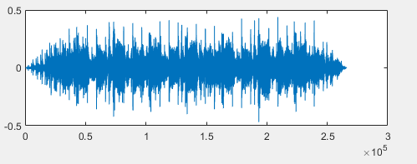

**Figure-11:** Both Methods applied on Pure Music signal

Although the overall quality of the audio has been hurt due to extensive compression, the music is still audible and different instruments are recognizable. The file also more than halved in size, dropping down to 353KB from 733KB, a reduction of roughly %48.

Different values have been testes for this case and the result has always been similar to the results from the previous section. Although the distortion resulting from DSE method is masked by DCTC compression to a degree.

### Pure Speech Signal

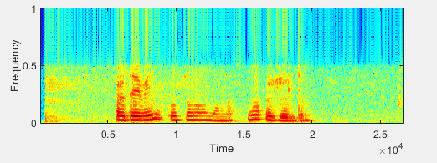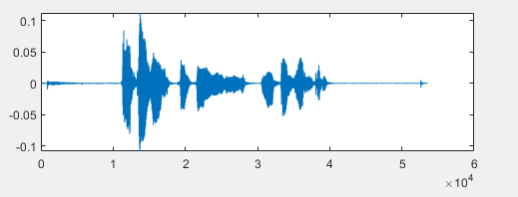

**Figure-12:** Both methods applied on pure speech signal

The graphs given in ***Figure-12*** are obtained by setting the frame length as 5ms, DCTC compression factor to 2 and DSE factor to 5% reduction. The resulting audio has little to no damage to its perceived quality with only a slight change to speaker’s pitch period.

## Results Evaluation

Overall results have shown that both compression algorithms are viable solutions under certain circumstances. While DCTC can be applied in majority of the cases, it causes music to sound blurry, DSE on the other hand can be applied to music with only slight distortion but also DSE performs worse in terms of perceived quality than DCTC. Due to how each method works, DCTC performs better as the compression is higher and is lossless. DSE still does a considerable compression at the cost of marginal perceived quality but not as much as the other method.

# Development

Although both compression methods applied works, there have been certain unexpected behavior from sample elimination method. The observable *clipping* noise from this method was originally thought to be due to bad smoothing. After improving the smoothing of the removed samples, the clipping noise still occurred albeit at a much lower magnitude. After testing with different values for ***frameLengthSeconds, scalingFactor*** and ***overlapRatio*** its observed that the noise was periodic at a frequency depending on all of these values. By changing the specifications of the frame, a linear relation has been observed and by changing scaling factor a non-linear relation has been observed. This is mostly due to the method’s tendency to remove samples that are in a drastic transition. Which means that the next or previous sample is much lower or much higher in magnitude compared to the sample that is going to be removed. By taking lower window sizes, the average threshold also changes, eliminating these drastic transitions. This is the primary reason for picking lower frame sizes in this project. This problem can be mended by implementing an extra check while marking the samples to make sure the previous and next samples are no more different in terms of magnitude by a percentage of the sample that is going to be marked.

Further work can also be done on the overall system to optimize the rate of which optimization is done on larger files. Although out of the scope of this project, the combination of these methods is relatively slow due to lack of optimization.

# Conclusions

Overall, apart from the implementation of a commonly used compression method such as DCTC, the work done on the second method which can be described as a chimera between temporal masking and time-based compression methods has been mostly fallen on the initiative. As the implementation of this method required algorithm design steps to be applied by analyzing the problem, creating design specifications and creating prototypes etc. Overall results from both methods have shown how the different types of audio files such as music and speech are affected by these methods differently. Testing with different parameters have shown effect of lossy and lossless compression on an audio signal in different scales and in turn resulted in how the frequency response of an audio signal changes and what causes damage to the integrity of the audio signals.

In conclusion, the compression methods that are built and tested in this project shows how two completely different types of compression effect and audio signal and what changes take place when the parameters of these methods are changed.

References

[1] Audio Compression, Henrik Hofling, Teodor Berglund, Axel Vaara, 2002, <http://www.signal.uu.se/Courses/CourseDirs/SignSyst/rapporter/AudioHBV.pdf>

[2] Digital Audio Compression, Davis Yen Pan, <http://www.dsp-book.narod.ru/DAC.PDF>

[3] Critical Bands in Human Hearing, ‘smacdon’, 2017, <https://community.plm.automation.siemens.com/t5/Testing-Knowledge-Base/Critical-Bands-in-Human-Hearing/ta-p/416798>

[4] Fundamentals of Multimedia: International Edition, Ze-Nian Li, Mark S Drew, Chp. 1.4.2, Chp 6

[5] Audio Compression based on discrete cosine transform, run length and high order shift encoding, Zainab T. DRWEESH, Loay E.GEORGE, July 2014, <http://www.ijeit.com/Vol%204/Issue%201/IJEIT1412201407_08.pdf>

1.